**Name : Chinmay Makrand Pimpalgaonkar**

**Student ID : WDGET2024026**

**Email ID:** [**chinmaymp007@gmail.com**](mailto:chinmaymp007@gmail.com)

**JDBC Airline Application**

--------------------------------------------------------------------------------------------------------------------------

**Github URL :** [**https://github.com/chinmay-2002/ServerRequestUsingSessionAndCookie.git**](https://github.com/chinmay-2002/ServerRequestUsingSessionAndCookie.git)

**Passenger.java**

**package** com.data;

**public** **class** Passenger {

**private** **long** adhar;

**private** String name;

**private** String dob;

**private** String sex;

**private** String address;

**private** **int** flightid;

**public** Passenger(**long** adhar, String name, String dob, String sex, String address, **int** flightid) {

**super**();

**this**.adhar = adhar;

**this**.name = name;

**this**.dob = dob;

**this**.sex = sex;

**this**.address = address;

**this**.flightid = flightid;

}

**public** **long** getAdhar() {

**return** adhar;

}

**public** **void** setAdhar(**long** adhar) {

**this**.adhar = adhar;

}

**public** String getName() {

**return** name;

}

**public** **void** setName(String name) {

**this**.name = name;

}

**public** String getDob() {

**return** dob;

}

**public** **void** setDob(String dob) {

**this**.dob = dob;

}

**public** String getSex() {

**return** sex;

}

**public** **void** setSex(String sex) {

**this**.sex = sex;

}

**public** String getAddress() {

**return** address;

}

**public** **void** setAddress(String address) {

**this**.address = address;

}

**public** **int** getFlightid() {

**return** flightid;

}

**public** **void** setFlightid(**int** flightid) {

**this**.flightid = flightid;

}

}

**Flight.java**

**package** com.data;

**public** **class** Flight {

**private** **int** flightid;

**private** String name;

**private** **int** seats;

**public** Flight(**int** flightid, String name, **int** seats) {

**super**();

**this**.flightid = flightid;

**this**.name = name;

**this**.seats = seats;

}

**public** **int** getFlightid() {

**return** flightid;

}

**public** **void** setFlightid(**int** flightid) {

**this**.flightid = flightid;

}

**public** String getName() {

**return** name;

}

**public** **void** setName(String name) {

**this**.name = name;

}

**public** **int** getSeats() {

**return** seats;

}

**public** **void** setSeats(**int** seats) {

**this**.seats = seats;

}

}

**AirlineManager.java**

**import** java.rmi.server.~~Operation~~;

**import** java.util.NoSuchElementException;

**import** java.util.Scanner;

**import** com.data.Passenger;

**import** com.operation.DatabaseManager;

**import** com.operation.Operations;

**public** **class** AirlineManager {

**public** **static** **void** main(String[] args) {

// **TODO** Auto-generated method stub

Operations op = **new** Operations();

Scanner sc = **new** Scanner(System.***in***);

DatabaseManager dm = **new** DatabaseManager();

**int** choice = 0;

System.***out***.println("XXXXXXXXXXXXXXXXXXXXXXXXXXXXXXXXXXXXXXXXXXXXXXXXXXXXX");

System.***out***.println("---------SHRI SHRI CHINMAY JI AIRLINE SERVICES-------");

System.***out***.println("XXXXXXXXXXXXXXXXXXXXXXXXXXXXXXXXXXXXXXXXXXXXXXXXXXXXX");

**while** (**true**) {

System.***out***.println("1. Insert Passenger Details");

System.***out***.println("2. Insert Flight Details");

System.***out***.println("3. Book Ticket");

System.***out***.println("4. Cancel Ticket");

System.***out***.println("5. Display Vacancy Seat Details");

System.***out***.println("6. Update Passenger Information");

System.***out***.println("7. Update Flight Details");

System.***out***.println("8. Exit");

System.***out***.print("Enter your choice: ");

choice = sc.nextInt();

sc.nextLine();

**switch** (choice) {

**case** 1:

op.insertPassengerDetails(dm);

**break**;

**case** 2:

op.insertFlightDetails(dm);

**break**;

**case** 3:

op.bookTicket(dm);

**break**;

**case** 4:

op.cancelTicket(dm);

**break**;

**case** 5:

op.displayVacant(dm);

**break**;

**case** 6:

op.updatePassengerDetails(dm);

**break**;

**case** 7:

op.updateFlightDetails(dm);

**break**;

**case** 8:

op.closeConnection(dm);

System.***out***.println("Exiting... Bye Bye");

System.***out***.println("I hope You loved SHRI SHRI CHINMAY JI's AIRLINE service!");

System.***out***.println("xxxxxxxxxxxxxxxxxxxxxxxxxxxxxxxxxxxxxxxxxxxxxxxxxxxxxxxxxxxxxxxxxxxxxx");

System.*exit*(0);

**break**;

**default**:

System.***out***.println("Invalid choice. Please try again.");

}

}

}

}

**Operations.java**

**package** com.operation;

**import** java.sql.DriverManager;

**import** java.util.Scanner;

**import** com.data.Flight;

**import** com.data.Passenger;

**public** **class** Operations {

**public** **void** insertPassengerDetails(DatabaseManager dm) {

Scanner sc = **new** Scanner(System.***in***);

System.***out***.println("--------------------------------------------");

System.***out***.println("Enter Passenger Adhar ID :");

**long** adhar = sc.nextLong();

System.***out***.println("Enter Passenger Name :");

sc.nextLine();

String name = sc.nextLine();

System.***out***.println("Enter Passenger Gender :");

String gender = sc.nextLine();

// sc.nextLine();

System.***out***.println("Enter Passenger Date of Birth in dd-mm-yyyy :");

String dob = sc.nextLine();

// sc.nextLine();

System.***out***.println("Enter Passenger Address :");

String address = sc.nextLine();

Passenger ps = **new** Passenger(adhar, name, dob,gender, address, 0);

dm.insertPassenger(ps);

}

**public** **void** insertFlightDetails(DatabaseManager dm) {

Scanner sc = **new** Scanner(System.***in***);

System.***out***.println("--------------------------------------------");

System.***out***.println("Enter Flight ID :");

**int** id = sc.nextInt();

System.***out***.println("Enter Flight Name :");

String name = sc.next();

System.***out***.println("Enter Availaible Seats :");

**int** seats = sc.nextInt();

Flight f = **new** Flight(id, name, seats);

dm.insertFlight(f);

}

**public** **void** bookTicket(DatabaseManager dm) {

Scanner sc = **new** Scanner(System.***in***);

System.***out***.println("Enter Passenger Adhar :");

**long** adhar = sc.nextLong();

System.***out***.println("Enter Flight ID :");

**int** flightId = sc.nextInt();

dm.bookTicket(adhar, flightId);

}

**public** **void** cancelTicket(DatabaseManager dm) {

Scanner sc = **new** Scanner(System.***in***);

System.***out***.println("Enter Passenger Adhar to cancel Current Flight :");

**long** adhar = sc.nextLong();

dm.cancelTickett(adhar);

}

**public** **void** displayVacant(DatabaseManager dm) {

dm.displayVacantSeatsandFlights();

System.***out***.println("------------------------------------------------------");

}

**public** **void** updatePassengerDetails(DatabaseManager dm) {

Scanner scanner = **new** Scanner(System.***in***);

System.***out***.println("Enter Adhar number of the passenger: ");

**long** adhar = scanner.nextLong();

scanner.nextLine();

System.***out***.println("Select the column to update:");

System.***out***.println("1. Name");

System.***out***.println("2. Sex");

System.***out***.println("3. Date of Birth");

System.***out***.println("4. Address");

**int** choice = scanner.nextInt();

scanner.nextLine();

String columnName = "";

**switch** (choice) {

**case** 1:

columnName = "name";

**break**;

**case** 2:

columnName = "sex";

**break**;

**case** 3:

columnName = "dob";

**break**;

**case** 4:

columnName = "address";

**break**;

**default**:

System.***out***.println("Invalid choice.");

**return**;

}

System.***out***.println("Enter the new value for " + columnName + ": ");

String newValue = scanner.nextLine();

dm.updatePassenger(adhar, columnName, newValue);

}

**public** **void** updateFlightDetails(DatabaseManager dm) {

Scanner scanner = **new** Scanner(System.***in***);

System.***out***.println("Enter the flight ID: ");

**int** flightId = scanner.nextInt();

scanner.nextLine();

System.***out***.println("Select the column to update:");

System.***out***.println("1. Flight Name");

System.***out***.println("2. Seats");

**int** choice = scanner.nextInt();

scanner.nextLine();

String columnName = "";

**switch** (choice) {

**case** 1:

columnName = "flightname";

**break**;

**case** 2:

columnName = "seats";

**break**;

**default**:

System.***out***.println("Invalid choice.");

**return**;

}

System.***out***.println("Enter the new value for " + columnName + ": ");

String newValue = scanner.nextLine();

dm.updateFlight(flightId, columnName, newValue);

System.***out***.println("------------------------------------------------------");

}

**public** **void** closeConnection(DatabaseManager dm) {

dm.close();

}

}

**DatabaseManager.java**

**package** com.operation;

**import** java.sql.*;

**import** java.util.ArrayList;

**import** java.util.List;

**import** com.data.Flight;

**import** com.data.Passenger;

**public** **class** DatabaseManager {

**private** Connection connection;

**public** DatabaseManager() {

**try** {

connection = DriverManager.*getConnection*("jdbc:mysql://localhost:3307/chinmayairline", "root", "");

System.***out***.println("Connected to database!");

} **catch** (SQLException e) {

System.***out***.println("Exception occurs in Connection!");

e.printStackTrace();

}

}

**public** **void** insertPassenger(Passenger passenger) {

**try** {

PreparedStatement statement = connection.prepareStatement("INSERT INTO passengers VALUES (?, ?, ?, ?, ?, ?)");

statement.setLong(1, passenger.getAdhar());

statement.setString(2, passenger.getName());

statement.setString(3, passenger.getSex());

statement.setString(4, passenger.getDob());

statement.setString(5, passenger.getAddress());

statement.setInt(6, passenger.getFlightid());

statement.executeUpdate();

System.***out***.println("Passenger Added Successfully!");

System.***out***.println("--------------------------------------------");

System.***out***.println();

statement.close();

} **catch** (SQLException e) {

System.***out***.println("Exception occurs in Passenger Insertion!");

e.printStackTrace();

}

}

**public** **void** insertFlight(Flight flight) {

**try** {

PreparedStatement statement = connection.prepareStatement("INSERT INTO flights values (?, ?, ?)");

statement.setInt(1, flight.getFlightid());

statement.setString(2, flight.getName());

statement.setInt(3, flight.getSeats());

statement.executeUpdate();

System.***out***.println("Flight Added Successfully!");

System.***out***.println("--------------------------------------------");

statement.close();

} **catch** (SQLException e) {

System.***out***.println("Exception occurs in Flights Insertion!");

e.printStackTrace();

}

}

**public** **void** bookTicket(**long** passengerId, **int** flightId) {

**try** {

String checkSeatsQuery = "SELECT seats FROM flights WHERE id = ?";

PreparedStatement preparedStatement = connection.prepareStatement(checkSeatsQuery);

preparedStatement.setInt(1, flightId);

ResultSet resultSet = preparedStatement.executeQuery();

**if** (resultSet.next()) {

**int** availableSeats = resultSet.getInt("seats");

**if** (availableSeats > 0) {

// Book the ticket

String bookTicketQuery = "UPDATE passengers set flightid = ? where adhar = ?";

preparedStatement = connection.prepareStatement(bookTicketQuery);

preparedStatement.setInt(1, flightId);

preparedStatement.setLong(2, passengerId);

**int** rowsAffected = preparedStatement.executeUpdate();

**if** (rowsAffected > 0) {

// Update available seats

String updateSeatsQuery = "UPDATE flights SET seats = ? WHERE id = ?";

preparedStatement = connection.prepareStatement(updateSeatsQuery);

preparedStatement.setInt(1, availableSeats - 1);

preparedStatement.setInt(2, flightId);

**int** updatedRows = preparedStatement.executeUpdate();

**if** (updatedRows > 0) {

System.***out***.println("Opration Done!");

}

System.***out***.println("Ticket Booked Perfectly!");

System.***out***.println("-----------------------------------------------------");

}

} **else** {

System.***out***.println("Sorry, no available seats for this flight.");

}

} **else** {

System.***out***.println("Invalid flight ID.");

}

} **catch** (Exception e) {

e.printStackTrace();

}

}

**public** **void** cancelTickett(**long** passengerId) {

PreparedStatement preparedStatement = **null**;

**try** {

// Get the flight ID of the passenger

String getFlightIdQuery = "SELECT flightid FROM passengers WHERE adhar = ?";

preparedStatement = connection.prepareStatement(getFlightIdQuery);

preparedStatement.setLong(1, passengerId);

**int** flightId = 0;

**try** (ResultSet resultSet = preparedStatement.executeQuery()) {

**if** (resultSet.next()) {

flightId = resultSet.getInt("flightid");

}

}

// Cancel the passenger's ticket

String cancelTicketQuery = "UPDATE passengers SET flightid = 0 WHERE adhar = ?";

preparedStatement = connection.prepareStatement(cancelTicketQuery);

preparedStatement.setLong(1, passengerId);

**int** rowsAffectedPassenger = preparedStatement.executeUpdate();

// Increment available seats for the flight

String incrementSeatsQuery = "UPDATE flights SET seats = seats + 1 WHERE id = ?";

preparedStatement = connection.prepareStatement(incrementSeatsQuery);

preparedStatement.setInt(1, flightId);

**int** rowsAffectedFlight = preparedStatement.executeUpdate();

// If both updates were successful, set success flag to true

**if** (rowsAffectedPassenger > 0 && rowsAffectedFlight > 0) {

System.***out***.println("Ticket Canceled Successfully!!!");

System.***out***.println("------------------------------------------------------");

}

} **catch** (SQLException e) {

e.printStackTrace();

System.***out***.println("Got exception bro 1");

}

}

**public** **void** displayVacantSeatsandFlights() {

PreparedStatement preparedStatement = **null**;

ResultSet resultSet = **null**;

**try** {

String query = "SELECT id, flightname, seats FROM flights";

preparedStatement = connection.prepareStatement(query);

resultSet= preparedStatement.executeQuery();

// Print table header

System.***out***.println("------------------------------------------------------");

System.***out***.printf("%-10s %-20s %-10s%n", "Flight ID", "Flight Name", "Vacant Seats");

System.***out***.println("------------------------------------------------------");

// Print table rows

**while** (resultSet.next()) {

**int** flightId = resultSet.getInt("id");

String flightName = resultSet.getString("flightname");

**int** vacantSeats = resultSet.getInt("seats");

System.***out***.printf("%-10d %-20s %-10d%n", flightId, flightName, vacantSeats);

}

System.***out***.println("------------------------------------------------------");

} **catch** (SQLException e) {

e.printStackTrace();

}

}

**public** **void** updatePassenger(**long** adhar, String columnName, String newValue) {

PreparedStatement preparedStatement = **null**;

ResultSet resultSet = **null**;

**try** {

String updateQuery = "UPDATE passengers SET " + columnName + " = ? WHERE adhar = ?";

preparedStatement = connection.prepareStatement(updateQuery);

preparedStatement.setString(1, newValue);

preparedStatement.setLong(2, adhar);

**int** rowsAffected = preparedStatement.executeUpdate();

**if** (rowsAffected > 0) {

System.***out***.println("Passenger Details Updated Successfully!");

System.***out***.println("------------------------------------------------------");

} **else** {

System.***out***.println("No rows were updated. Please check the provided Adhar number.");

}

} **catch** (SQLException e) {

e.printStackTrace();

}

}

**public** **void** updateFlight(**int** flightId, String columnName, String newValue) {

PreparedStatement preparedStatement = **null**;

ResultSet resultSet = **null**;

**try** {

String updateQuery = "UPDATE flights SET " + columnName + " = ? WHERE id = ?";

preparedStatement = connection.prepareStatement(updateQuery);

preparedStatement.setString(1, newValue);

preparedStatement.setInt(2, flightId);

**int** rowsAffected = preparedStatement.executeUpdate();

**if** (rowsAffected > 0) {

System.***out***.println("Flights details Updated Successfully!");

} **else** {

System.***out***.println("No rows were updated. Please check the provided flight ID.");

}

} **catch** (SQLException e) {

e.printStackTrace();

}

}

**public** **void** close() {

**try** {

connection.close();

}

**catch**(Exception e) {

System.***out***.println("Failed to close connection!");

}

} }

**Outputs**

1. **Insert Passenger Details**

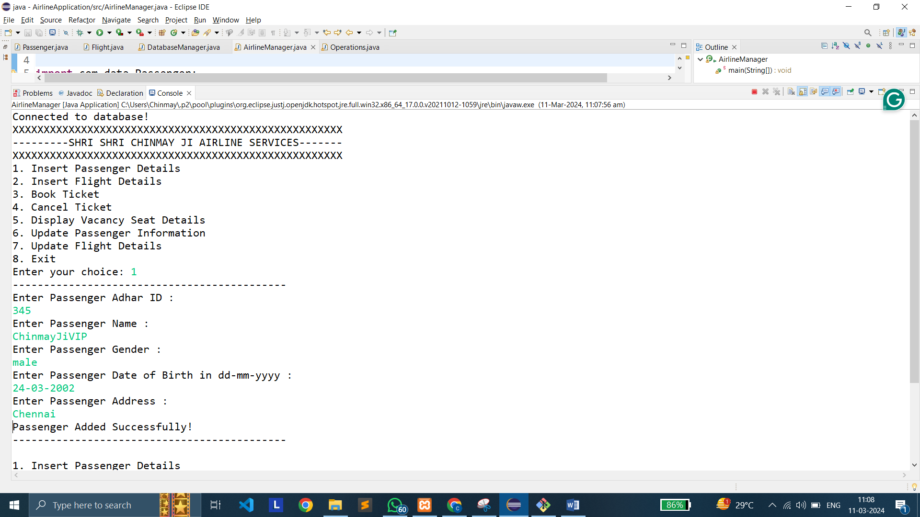

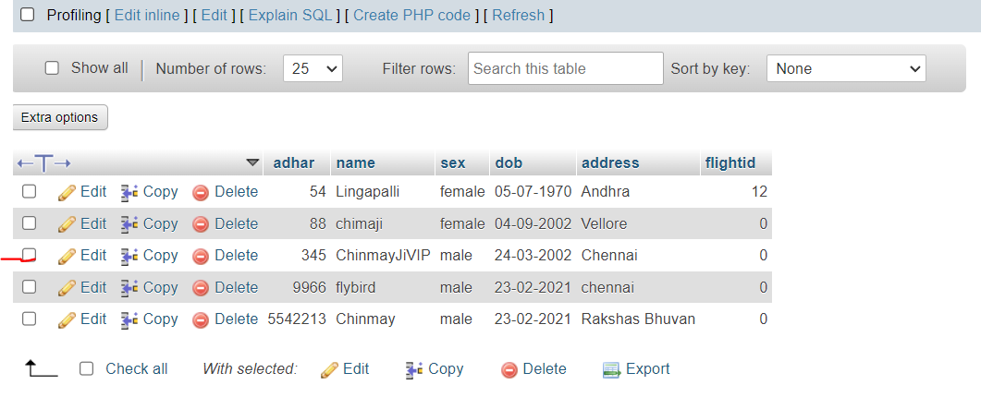

1. **Insert Flight Details**

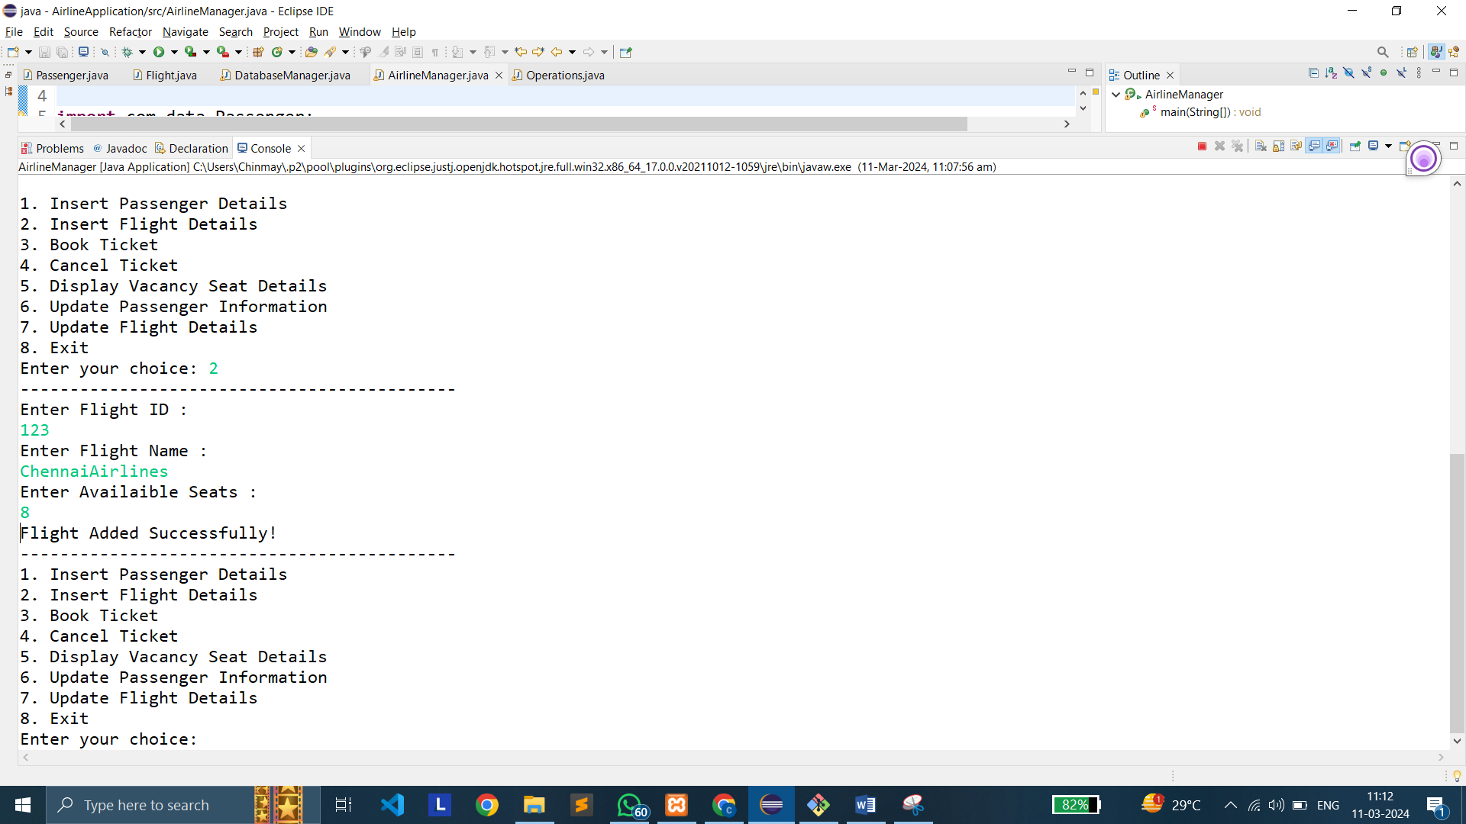

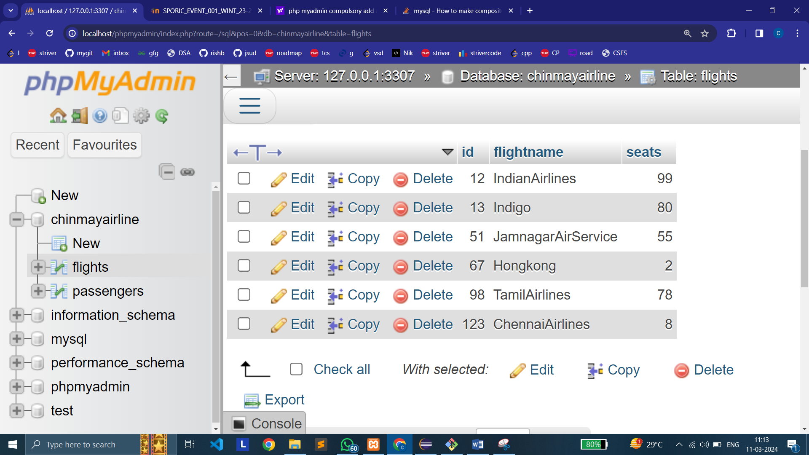

1. **Book Ticket**

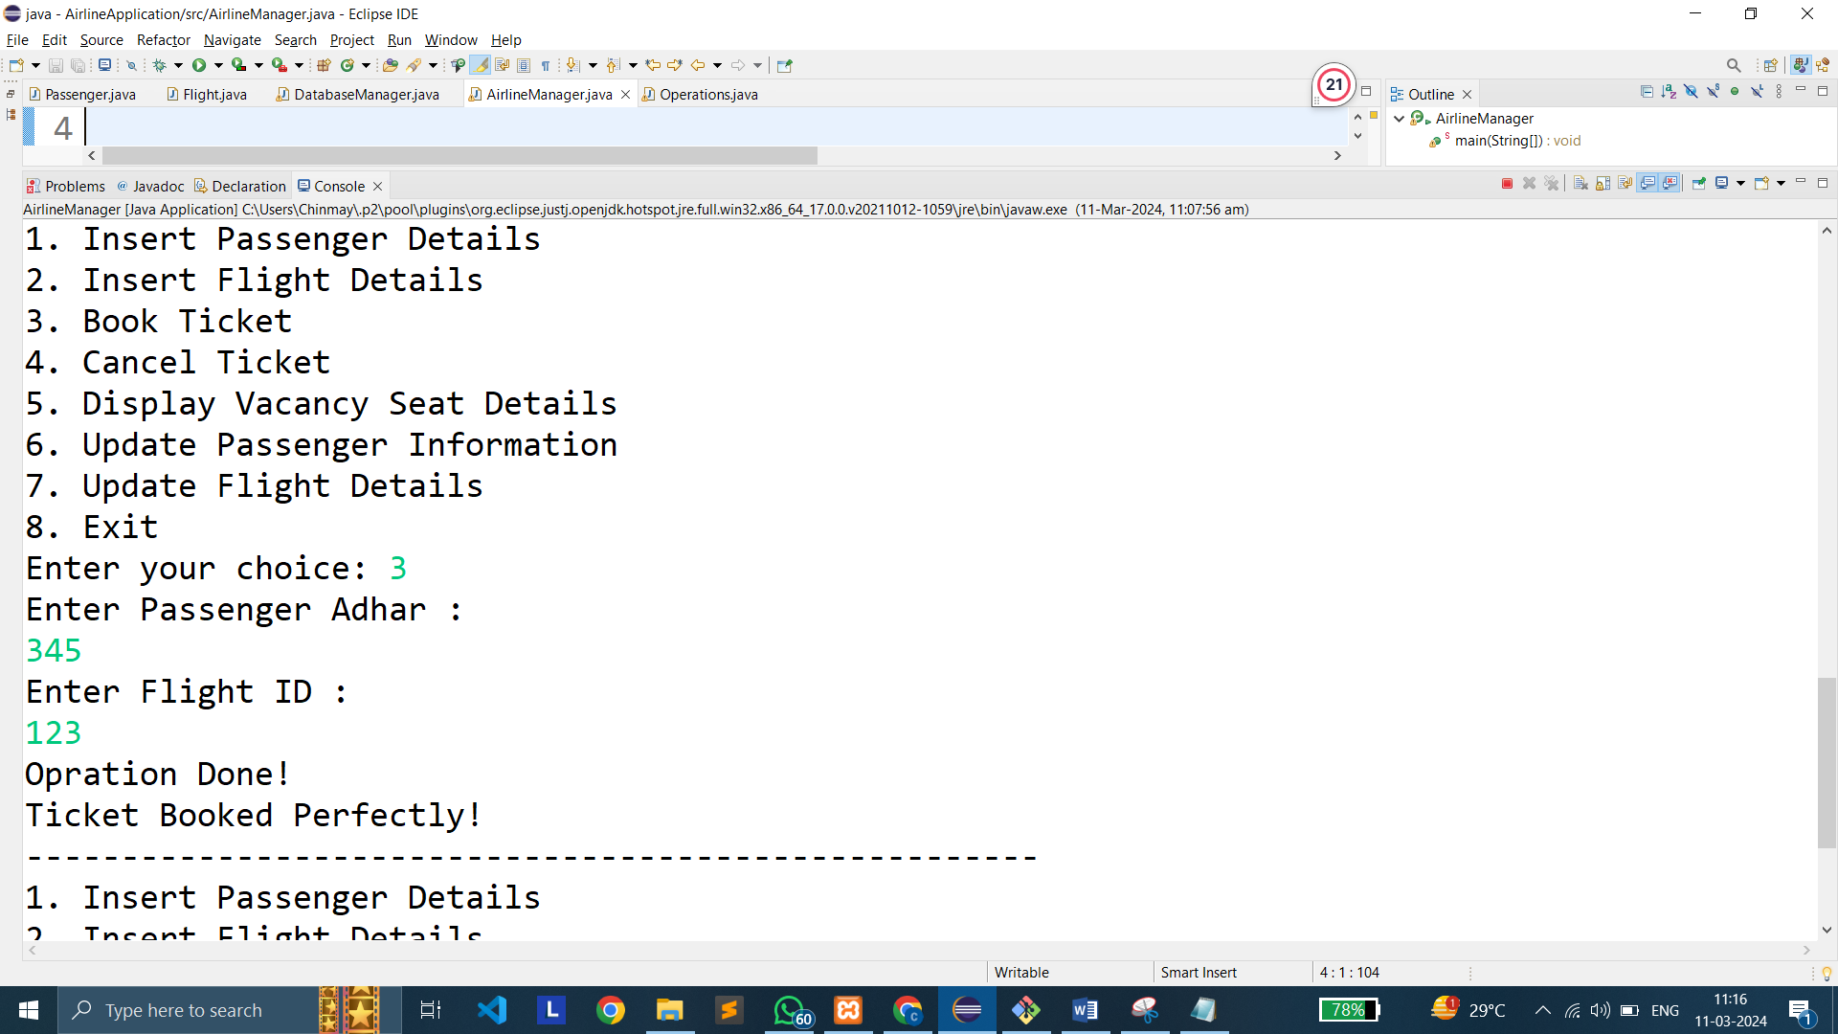

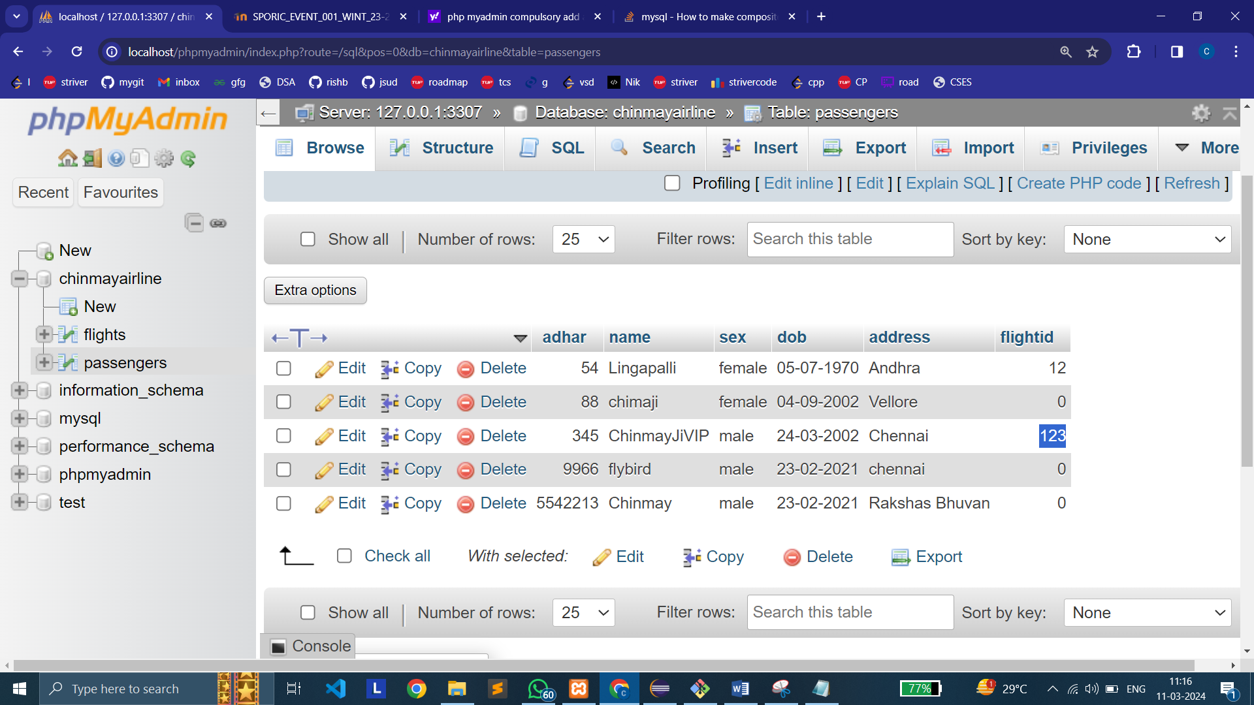

1. **Cancel Ticket**

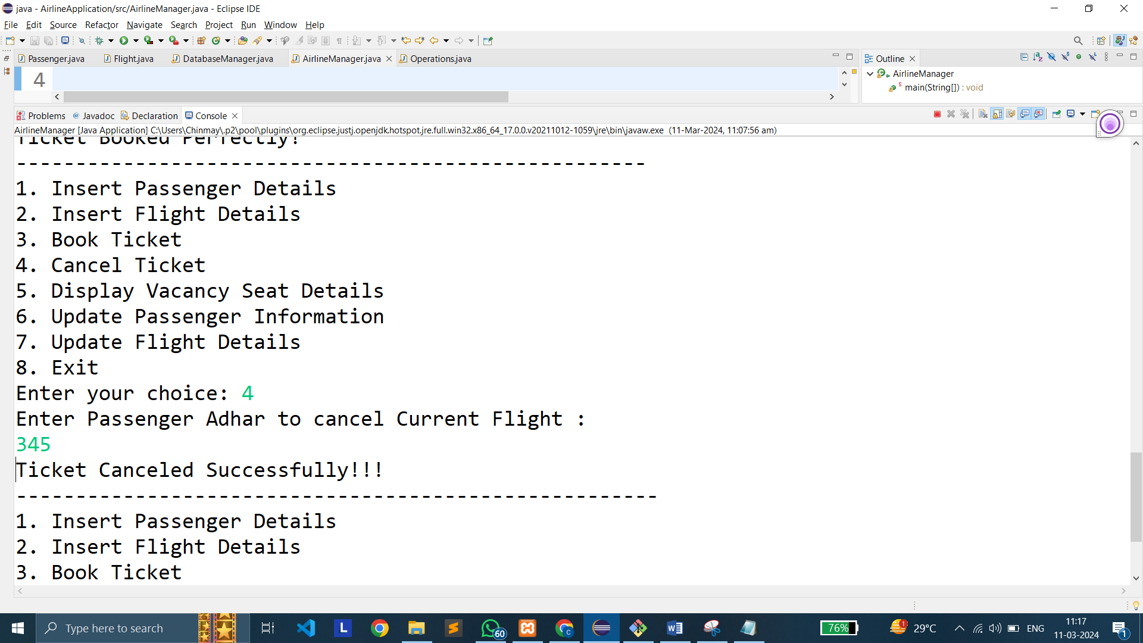

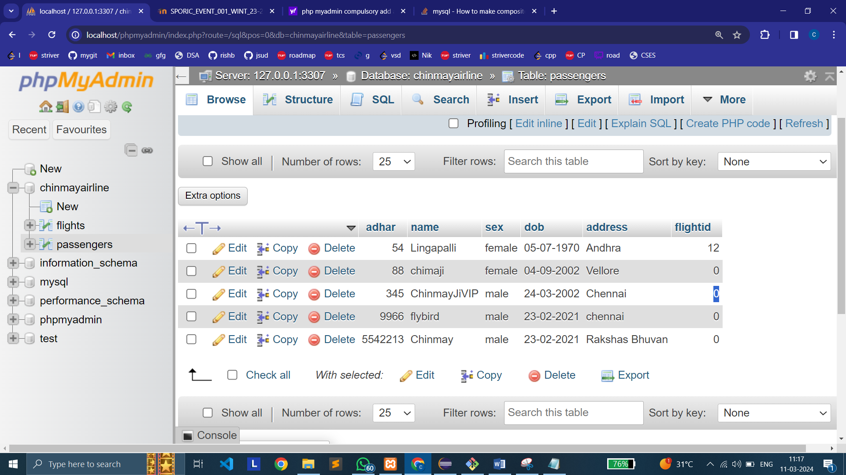

1. **Display Vacancy Seat Details**

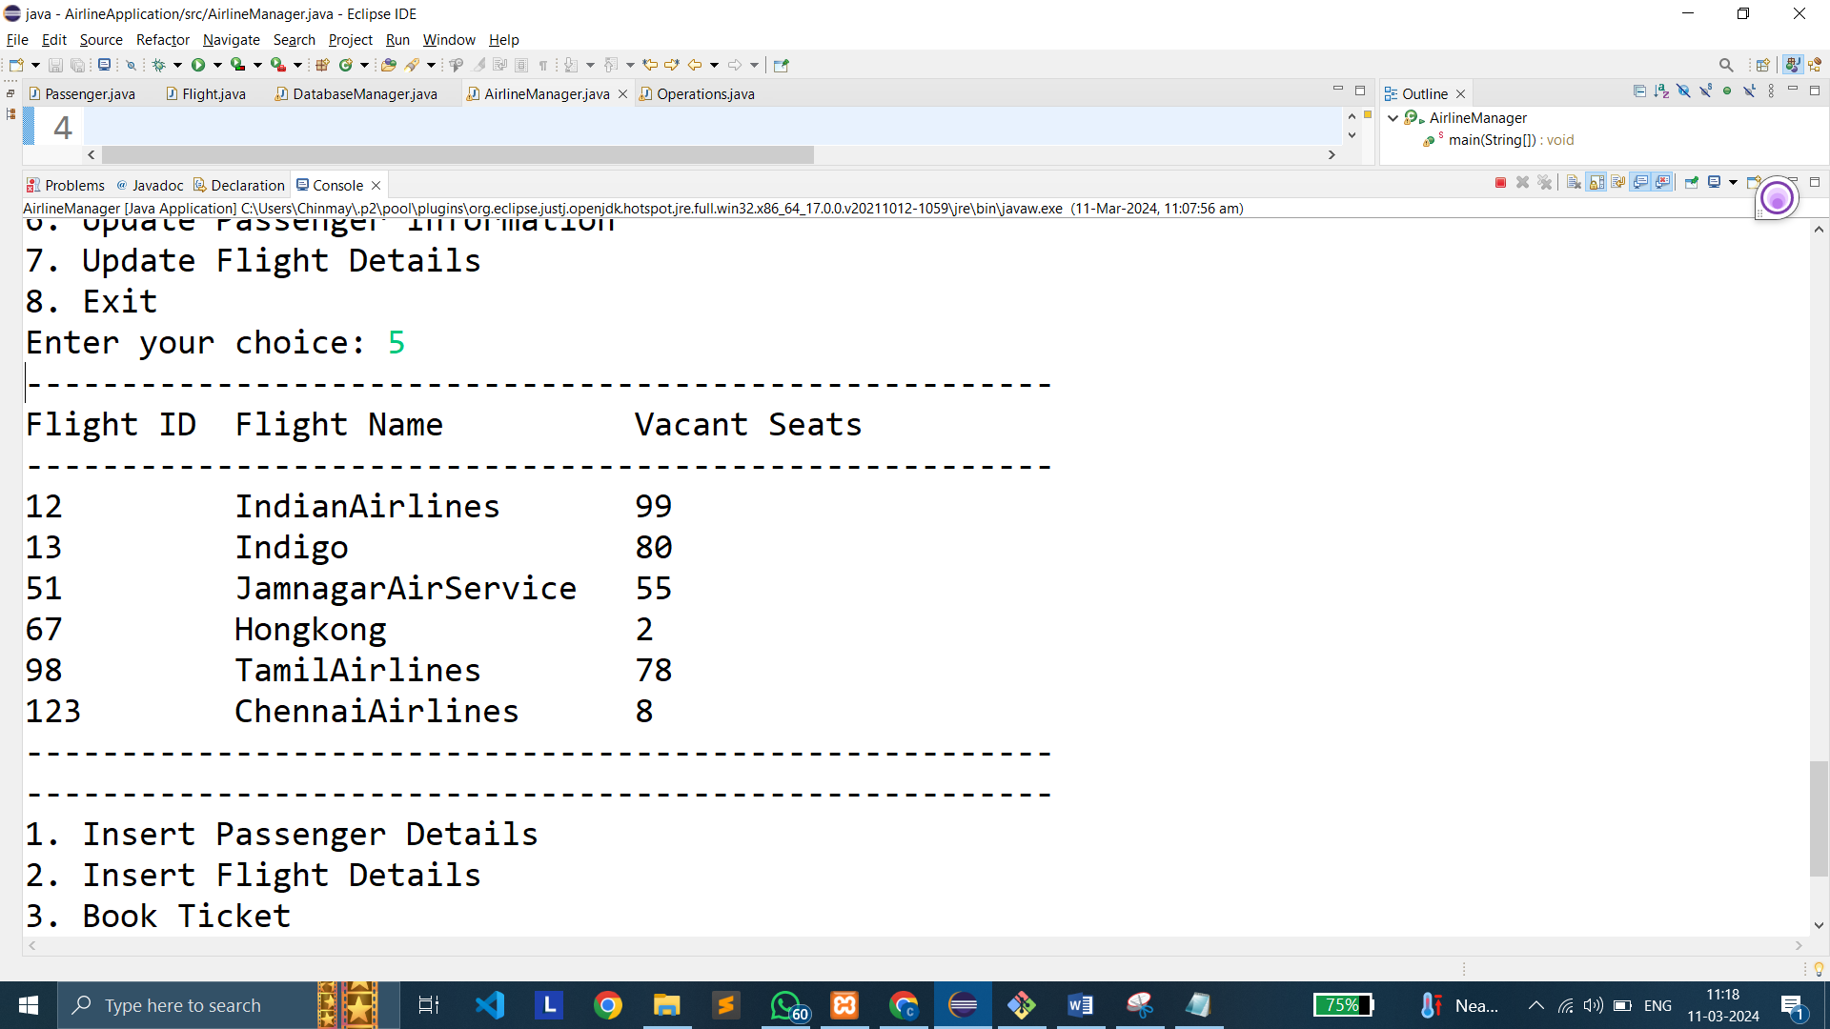

1. **Update Passenger Information**

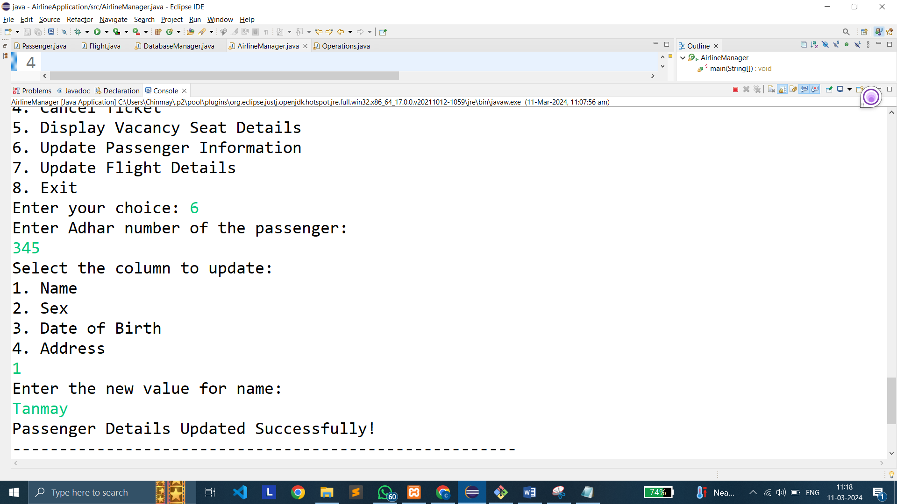

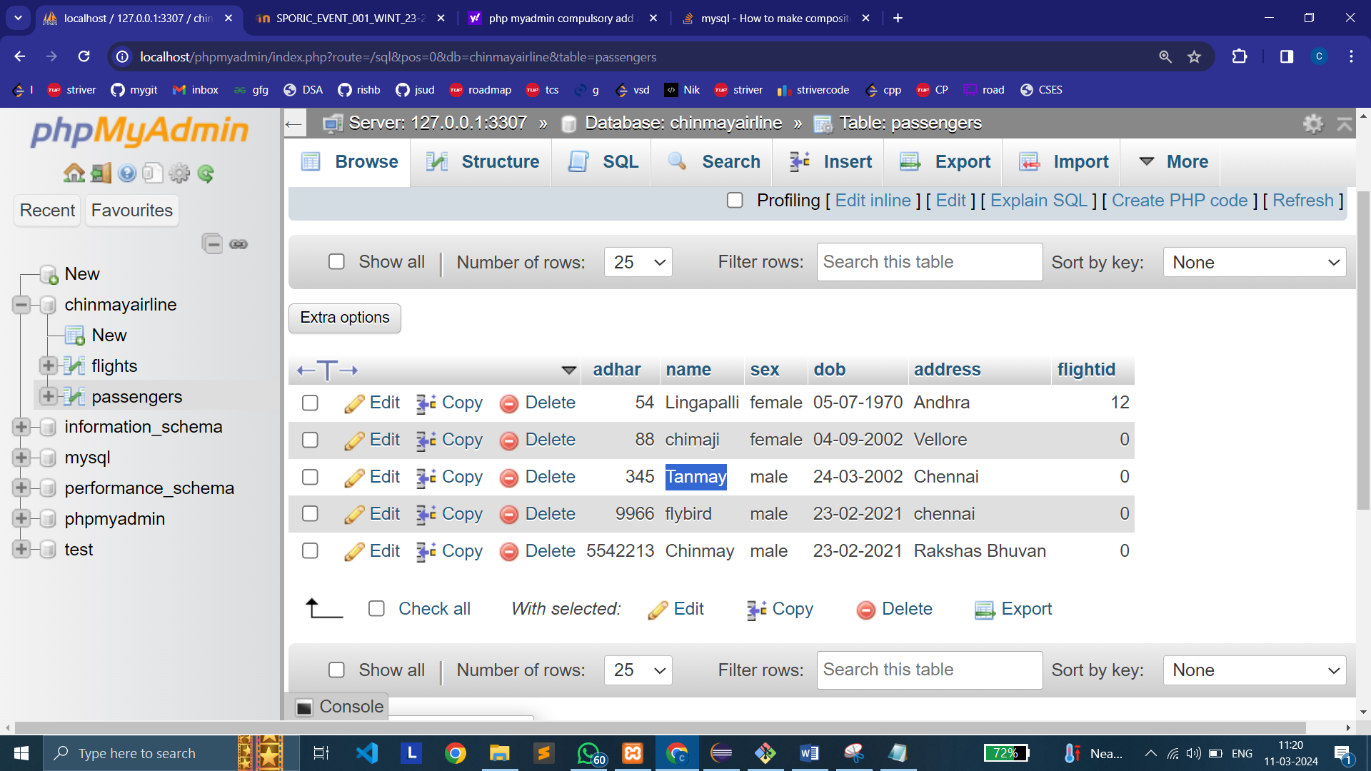

1. **Update Flight Details**

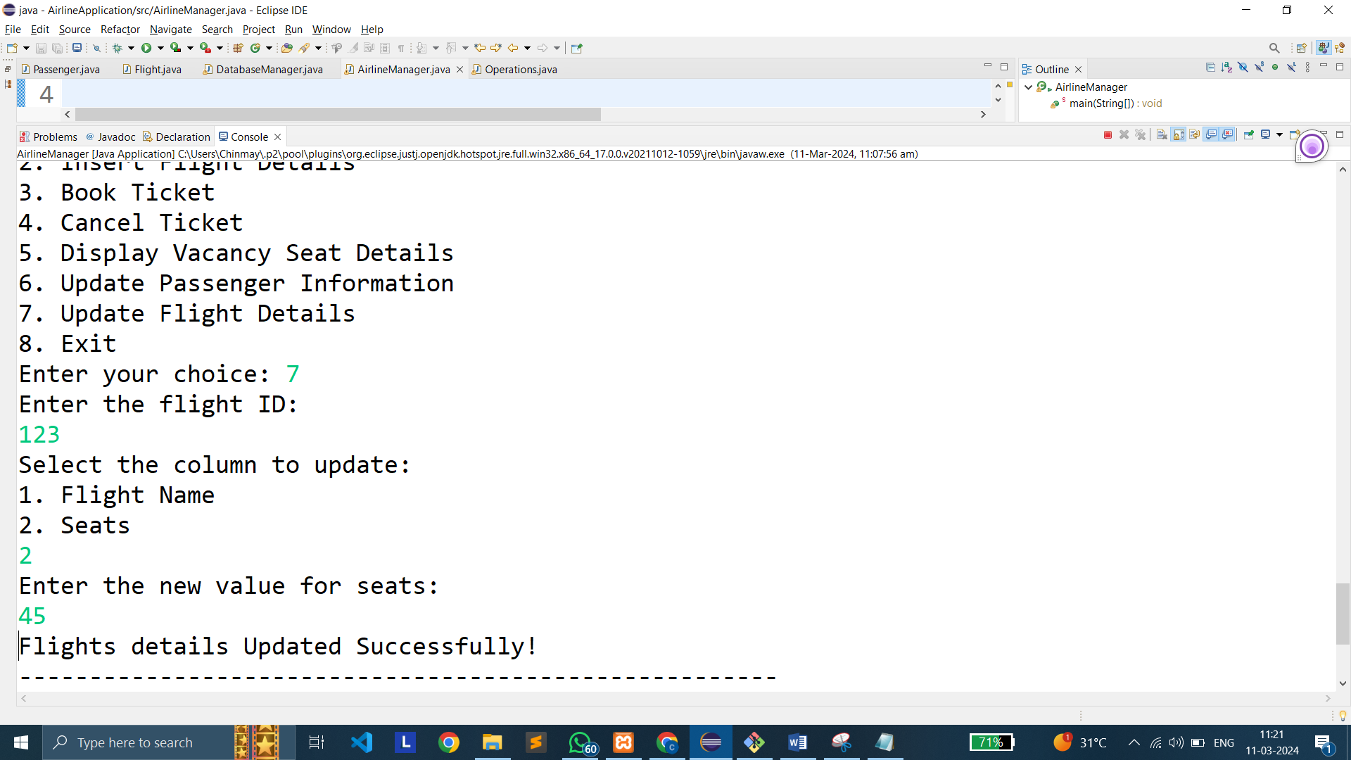

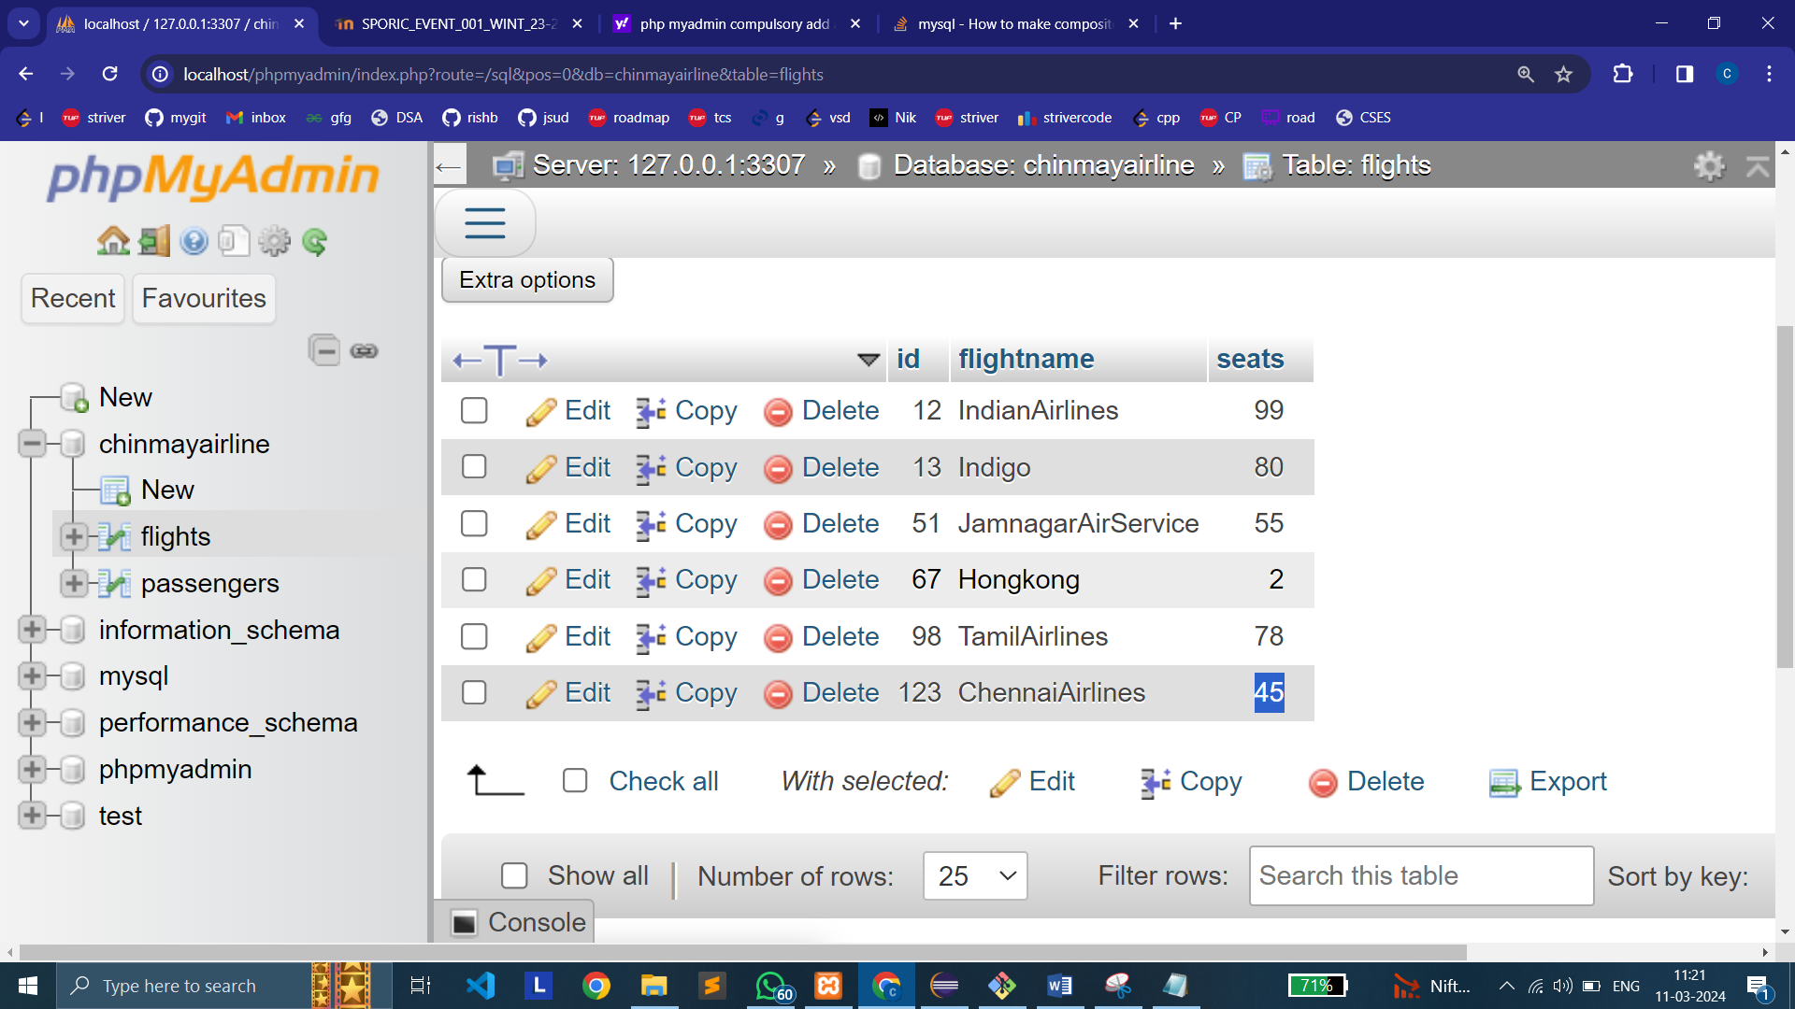

1. **Exit**

